**Working model Report**

## “Formulation of I-D Reservoir Simulator Using Black Oil Model “

Submitted for the partial fulfillment of the Master’s degree in Petroleum Engineering in the Department of Petroleum Engineering, IIT ISM Dhanbad

**Submitted by : Praveen Yadav(21MT0292)**

**Rajnish Singh (21MT0319)**

**Salil Pradhan(21MT0351)**

**Shankar Lal Dangi(21MT0382)**

**Year : 1st year**

**Course : M.Tech**

**Department : Petroleum Engineering**

**Project Guide : Dr. Neetish Maurya**

**Dr. Rajeev Upadhyay**

**Date of Submission**  **:** **02-05-2022**



**INDIAN INSTITUTE OF TECHNOLOGY(ISM),**

**DHANBAD, JHARKHAND**

**CONTENTS**

**Page No.**

1. Objective and Introduction 3
2. Types of Reservoir Model 4
3. Major step of Reservoir simulation 5-8
4. Step for formulation of Reservoir simulation 9-11
5. Result 12-14

## 

## ACKNOWLEDGMENT

We express our sincere gratitude to ISM (IIT) Dhanbad for facilitating the instrumentation of the project undertaken by us.

Our special thanks to our project guide **Prof. Neetish Maurya and Prof. Rajeev Upadhyay** for guiding and facilitating us technically in every aspect of the project and also in solving every qualm in regards to the project.

**Signature of student Signature of Project guide**

**Date:**

**Place: Dhanbad**

1. **OBJECTIVE**

Development of 1 – D Reservoir Simulator using Black oil model, assuming depletion drive mechanisms for the reservoir and block cantered grid block.

With the model build we will

1. Determine how pressure varies in each grid block with time.
2. Relative oil permeability curves.
3. How will Transmissibility changes with changing properties like relative permeability.
4. Formation volume factor and Gas solubility changes with time.
5. **INTRODUCTION**

The reservoir simulation technique makes it possible to gain insight into the recovery processes of a reservoir. To understand fluid flow and, by this, to evaluate the performance of oil and gas recovery methods, the petroleum engineer models the relevant physical and chemical processes by systems of partial differential equations. These equations account for mass and heat transfer. They include terms for gravity, capillary and viscous forces. Thermodynamic equilibrium conditions determine the number of existing phases, their composition and properties.

Reservoir simulation involves the numerical solution of such systems with a computer. A reservoir is a three-dimensional, heterogeneous, anisotropic rock body, filled up in homogenously with fluids of different composition. It is evident that a reservoir model can only be constructed mathematically.

.

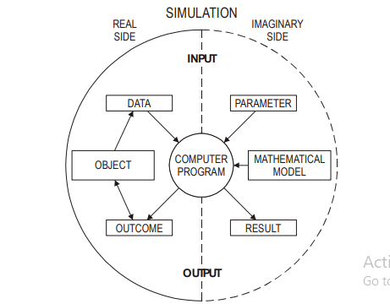

.

## TYPES OF RESERVOIR OIL MODEL

## BLACK OIL MODEL

## COMPOSITIONAL OIL MODEL

## BLACK OIL MODEL –

In this model, oil is treated as a single component with no interaction with the gas or water phases. This model is the most commonly used formulation of the reservoir simulation equations which is used for single, two and three phase reservoir processes. It treats the three phases - oil, gas and water - as if they were mass components where only the gas is allowed to dissolve in the oil and water. This gas solubility is described in oil and water by the gas solubility factors (or solution gas-oil ratios), Rs; these quantities are pressure dependent and this is incorporated into the black oil model.

The oil composition remains unchanged through the life of the Field.

## Reservoir processes that can be modeled using the black oil model include-

* Recovery by fluid expansion - solution gas drive (primary depletion)
* Water flooding including viscous, capillary and gravity forces (secondary recovery).
* Immiscible gas injection. Some three phase recovery processes such as immiscible wateralternating- gas.
* The oil composition remains unchanged through the life of the Field.

## The Compositional Model-

In this model the interaction between various hydrocarbon phases should be considered.

A compositional reservoir simulation model is required when significant inter-phase mass transfer effects occur in the fluid displacement process. This model usually defines three phases (again gas, oil and water) but the actual compositions of the oil and gas phases are explicitly acknowledged due to their more complicated PVT behaviour. That is, the separate components (C1, C2, C3, etc.) in the oil and gas phases are explicitly tracked. For example, in a near-critical fluid where small changes in say pressure can result in large compositional changes of the “oil” and “gas” phases which, in turn, strongly affects their physical properties (viscosity, density, interfacial tensions etc.).

## Reservoir processes that can be modeled using the compositional oil model include-

* Gas injection with oil mobilisation by first contact or developed (multi- contact)
* Miscibility (e.g. in CO2 flooding)
* The modelling of gas injection into near critical reservoirs.
* Gas recycling processes in condensate reservoirs.

## Major step of reservoir simulation -

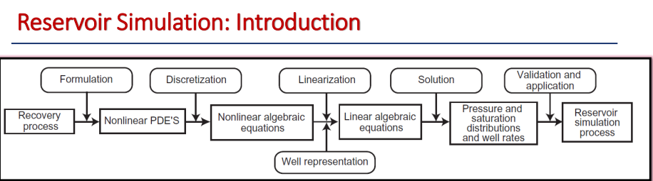

**Formulation** outlines the basic assumptions inherent to the simulator, states these assumptions in precise mathematical terms, and applies them to a control volume in the reservoir.

The result of this step is a set of coupled, nonlinear partial differential equations (PDEs) that describes fluid flow through porous media.

## Discretization is the process of converting PDEs into algebraic equations. Several numerical methods can be used to discretize the PDEs. The most common approach in the oil industry today is the finite difference method.

Reservoir is described by set of grid blocks whose properties, dimensions, boundaries, and locations in the reservoir are well defined. The discretization process results in a system of nonlinear algebraic equations. These equations generally cannot be solved with linear equation solvers, and the linearization of such equations becomes a necessary step before solutions can be obtained.

Two types of Reservoir discretization Grid**-**

* **Block centred grid**

Grid-Blocks with known dimensions are superimposed over the reservoir. For rectangular co-ordinate system, the grid points are defined as the centre of these grid blocks

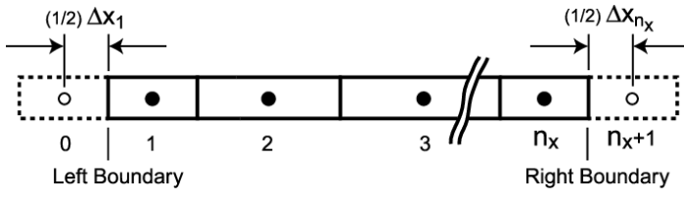

* **Point distributed grid**

• Grid points are distributed over the reservoir before the block boundaries are defined. For rectangular co-ordinate system, a block boundaries is placed halfway between two pressure points.

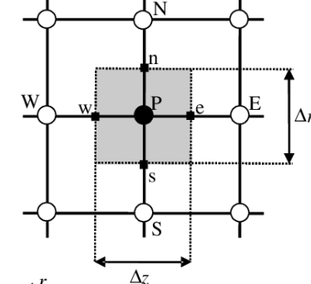

**Linearization** Involves approximating nonlinear terms (Transmissibility, production, coefficients etc.). Linearization results in a set of linear algebraic equations.

Validation of a reservoir simulator is the last step in developing a simulator, after which the simulator can be used for practical field applications. The validation step is necessary to make sure that no errors were introduced in the various steps of development or in computer programming.

**Final 1-D Differential Equation of Black Oil Model –**

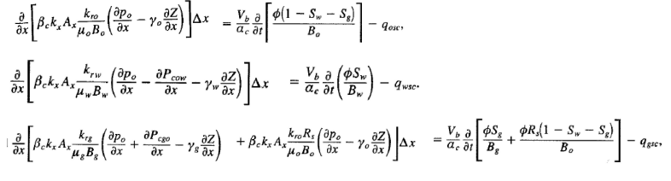

• This termed is called transmissibility, denoted as T, which contains all terms in Darcy Law expression for surface volumetric flow rate except for pressure. Transmissibility of a porous medium is considered to be the properties of porous medium, fluid flowing through it, direction of flow and position in space.

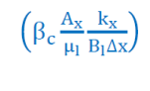

**Explicit and Implicit Finite Difference Formulation**

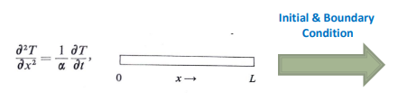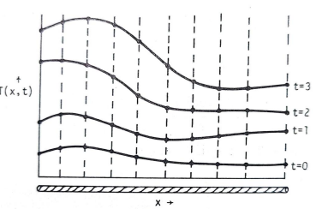

* A finite difference solution will provide discrete values at different times levels t=0,1,2,3.
* There are two ways in going from old time-level values to new time-level values ( for e.g t=0 to t=1)

1. **Explicit Scheme** The new values can be calculated individually for different location in space (X=0 to L)
2. **Implicit Scheme All** the values are collected simultaneously for different location in space (X=0 to L)

**Steps For the Formulation of reservoir simulator**

**Sample data used for formulation of simulator**

Permeability in x direction – 100 md

Length of grid block in x, y and z direction – 200, 100, 50

Total length of the reservoir – 350

Relative oil permeability of oil, water and gas – 0.5, 0.4, 0.1

Oil viscosity – 100 cp

Water viscosity – 1 cp

Gas viscosity – 0.005 cp

Initial oil, water and gas formation volume factor – 1.02, 1.1 and 0.006

Initial pressure of the reservoir – 5000 psi

Flow rate of the flowing reservoir – 500 bbl/day

Initial water and oil saturation – 0.4, 0.4

Porosity of the formation - 33%

O/W and O/G capillary pressure – 50 and 50 psi

Gas solubility at surface condition – 100 (low pressure), 400 (med pressure), 400 (high pressure)

Gas solubility at separator condition – 400 scf/STB

Gas specific gravity at standard condition – 0.8

Oil gravity – 0.8

Water specific gravity – 1.1

**Step 1** - Taking Various input form the user. we have to take various input from the user like reservoir dimension, initial water saturation, porosity, permeability etc.

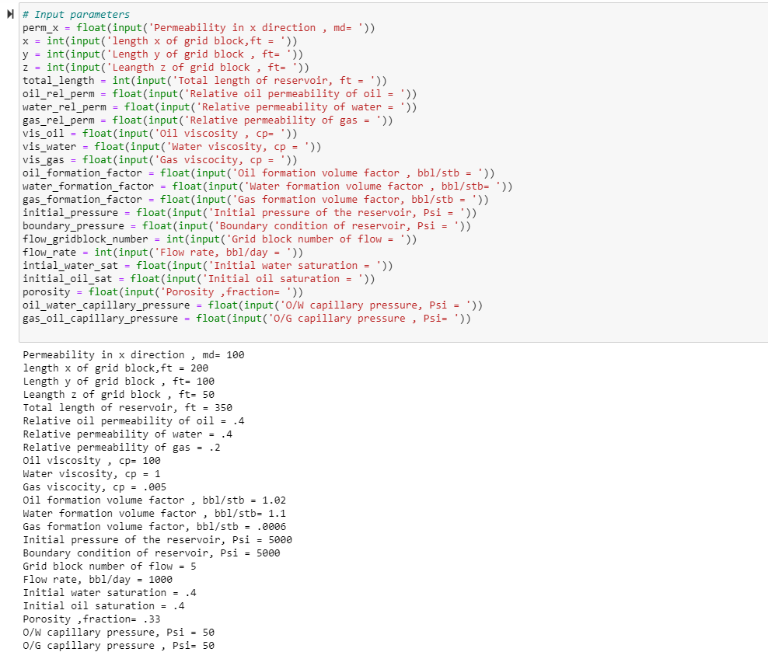

Input for the surface separator conditions for the calculation of specific gravity of oil and gas .

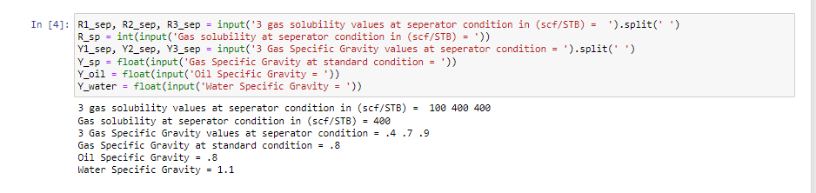

**Step 2 –**

Relative oil and gas saturation for the plotting the relative saturation curves.

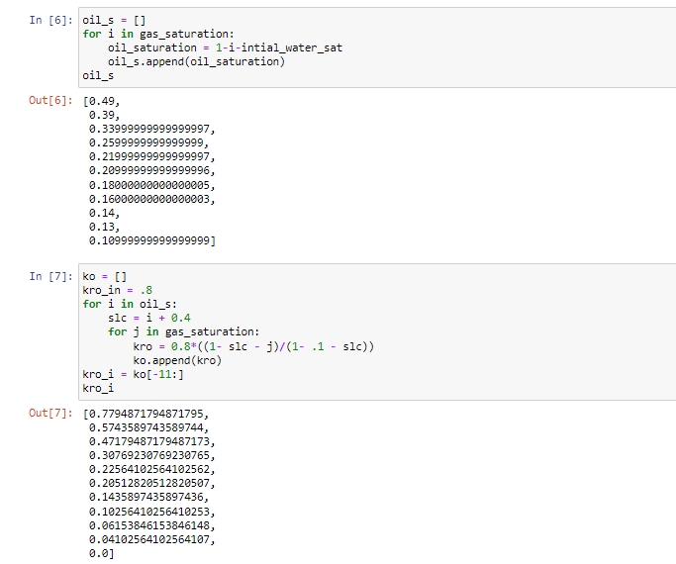

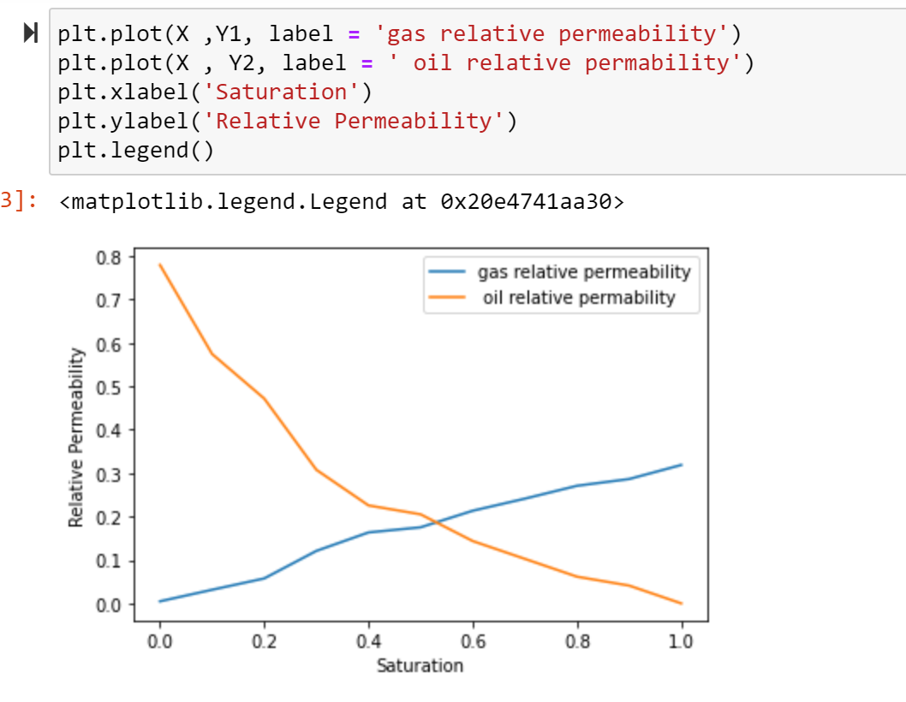

**STEP 3 –**

Pressure iterative term for the calculation of pressure in each grid block. (Time step = 10)

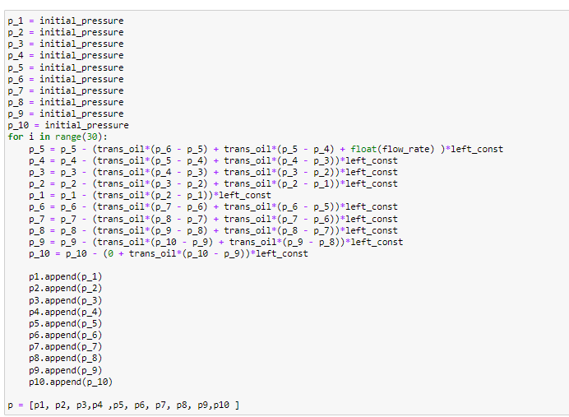

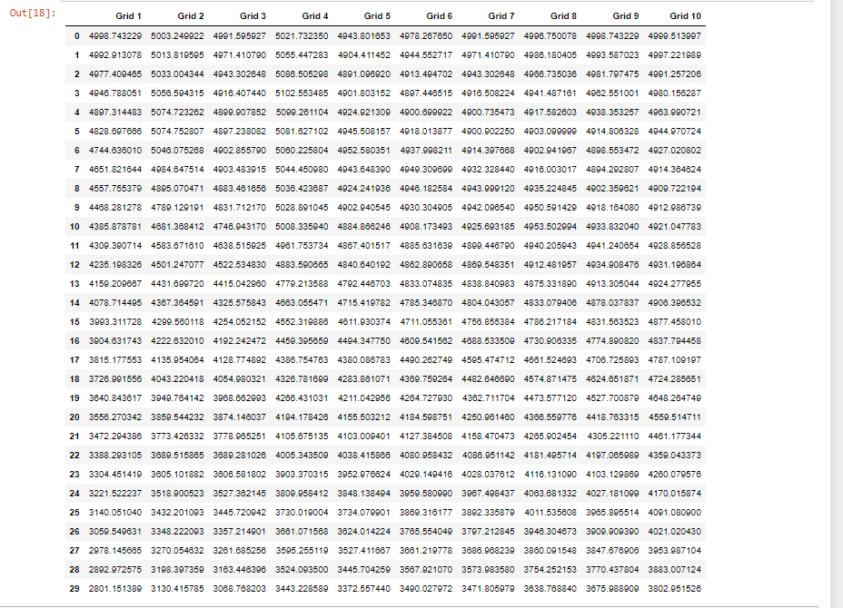

**RESULTS**

**Pressure of various grid block vs time**

**Number of Pressure Variation = 30**

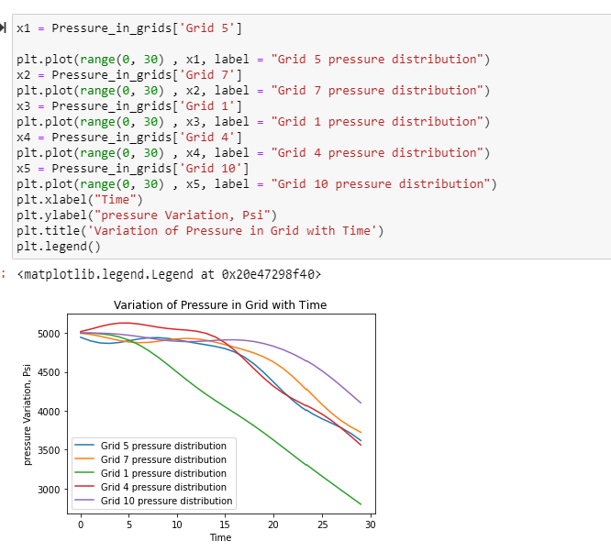

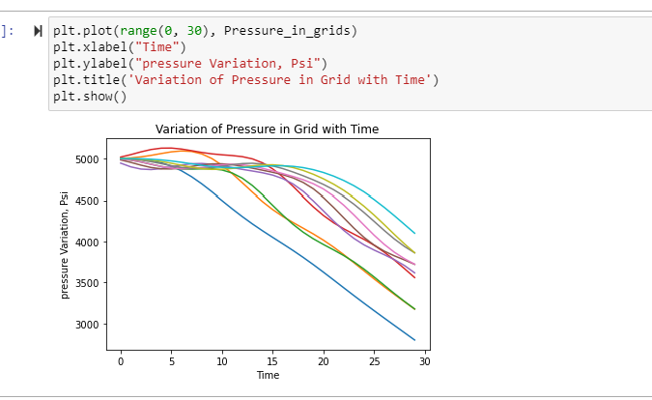

**Pressure of various grid block vs time**

**Number of Pressure Variation = 45**

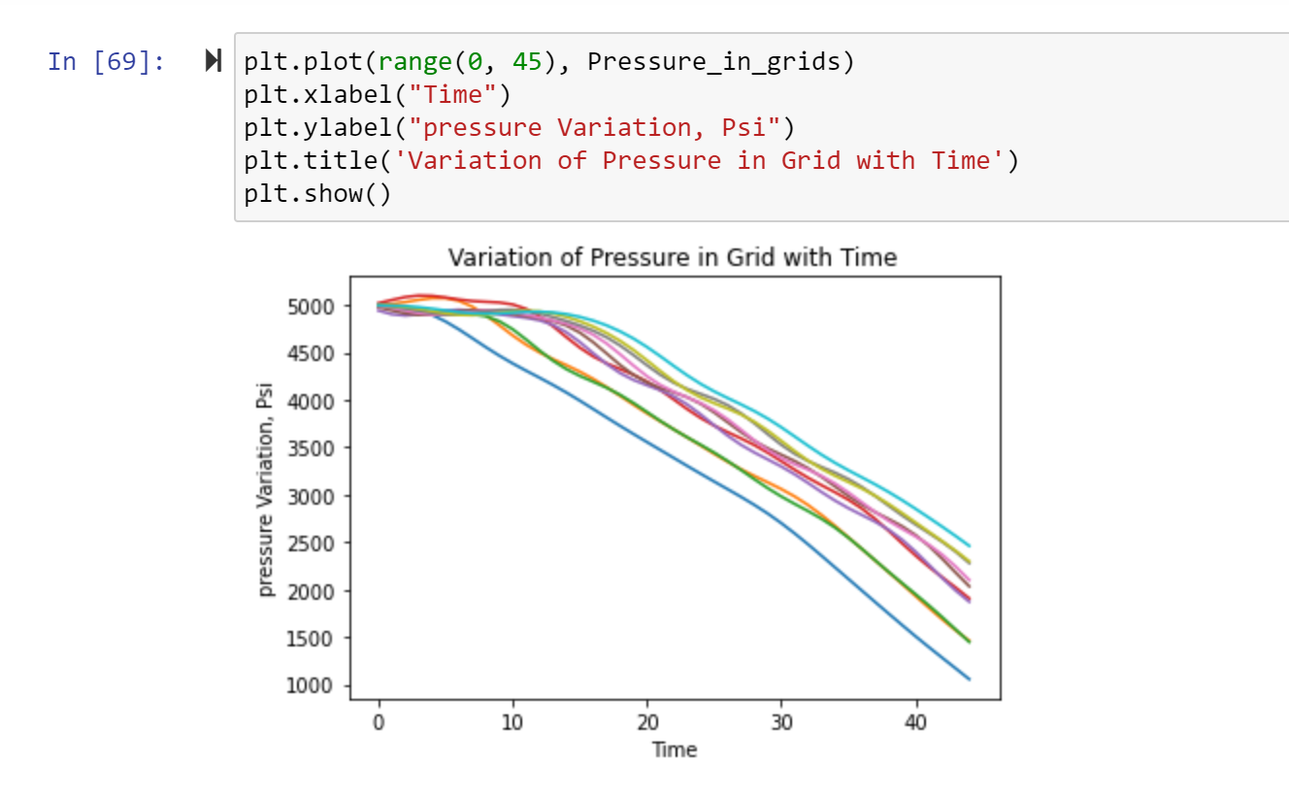

**Variation of time steps and their calculation of pressure.**

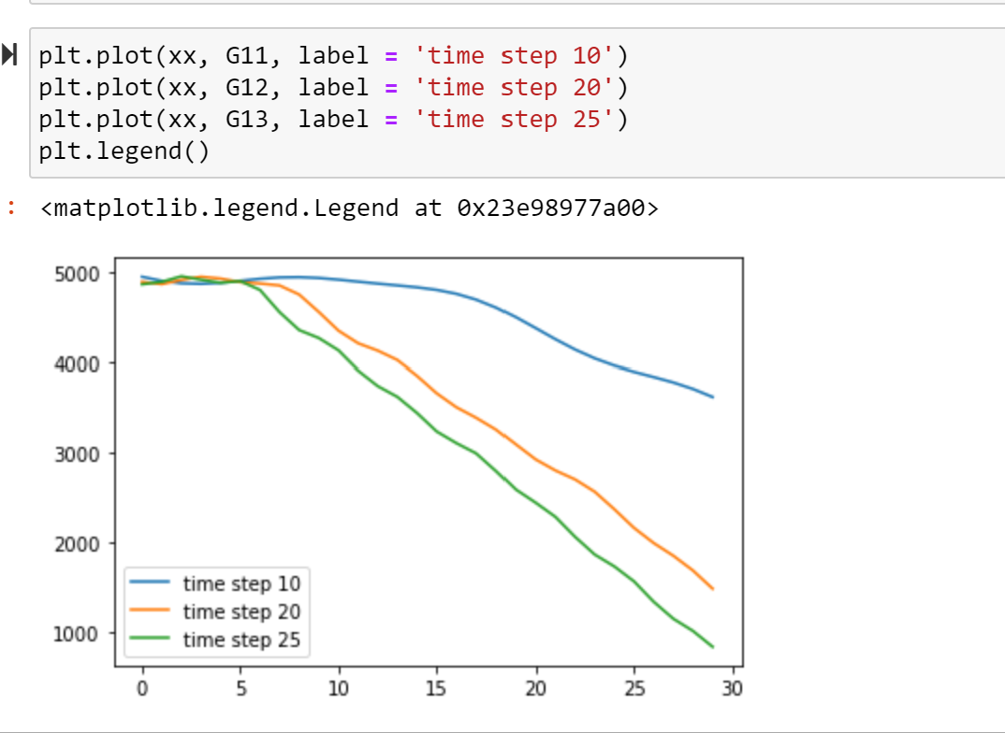

**Oil formation volume factor with pressure (Assuming below bubble point pressure)**

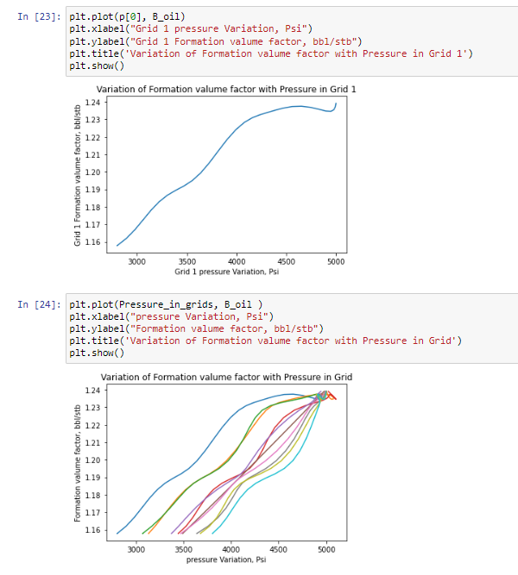

**Gas Solubility and Transmissibility at each grid block assuming pressure less than Bubble point**

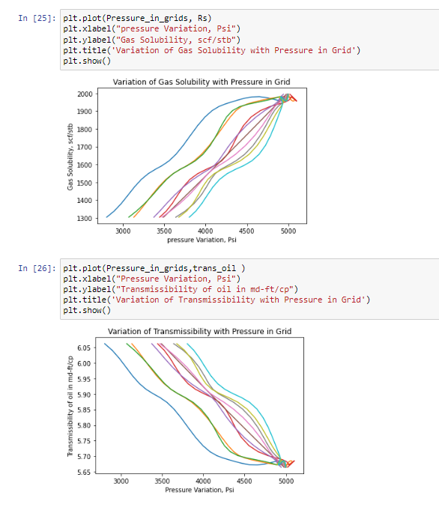

**Oil formation volume factor with pressure (Assuming below bubble point pressure)**

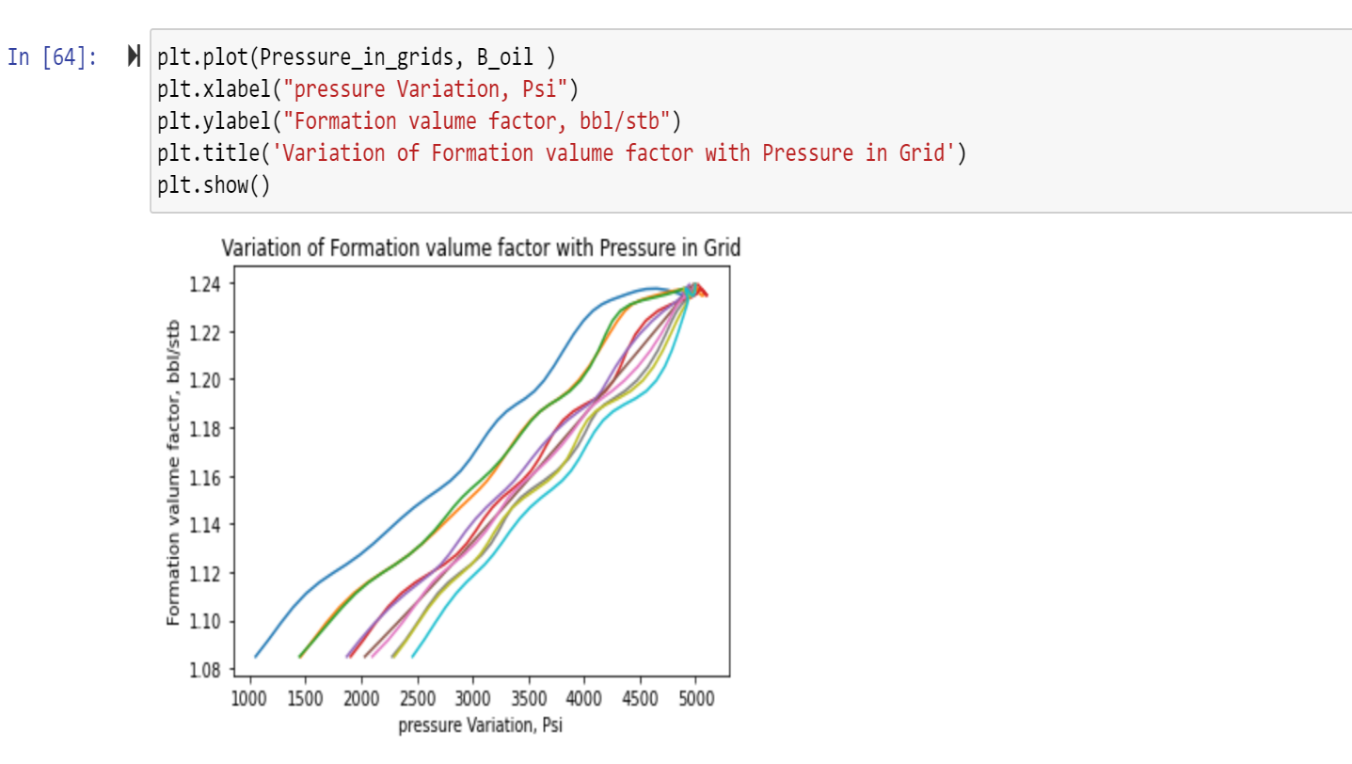

**Gas Solubility and Transmissibility at each grid block assuming pressure less than Bubble point**

